PROJECT REPORT TEMPLATE

# INTRODUCTION

A group of blood tests called liver function tests can be used to diagnose liver disease. Other blood tests can be done to look for specific liver problems or genetic conditions. Imaging tests. An ultrasound, CT scan and MRI can show liver damage.

## PROBLEM DEFINITION & DESIGN THINKING

EMPATHY MAP

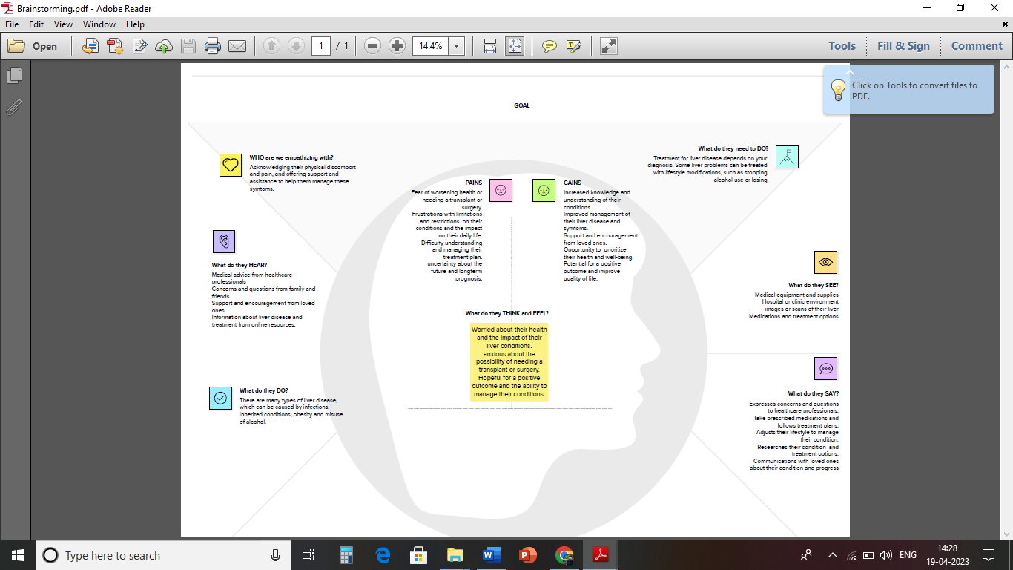

BRAINSTORMING MAP

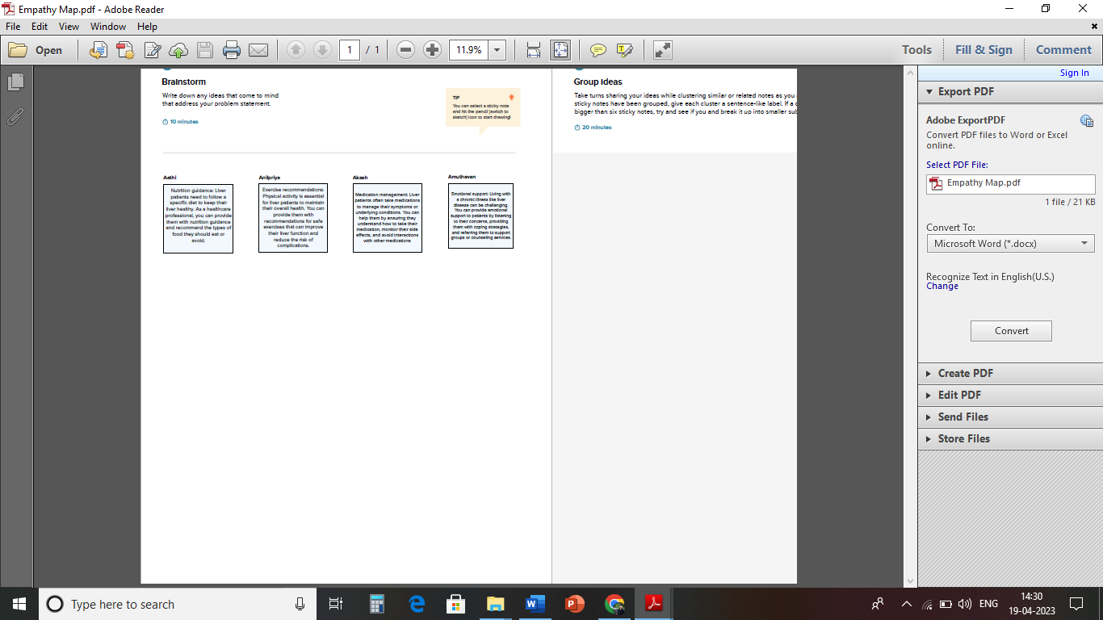

## RESULT

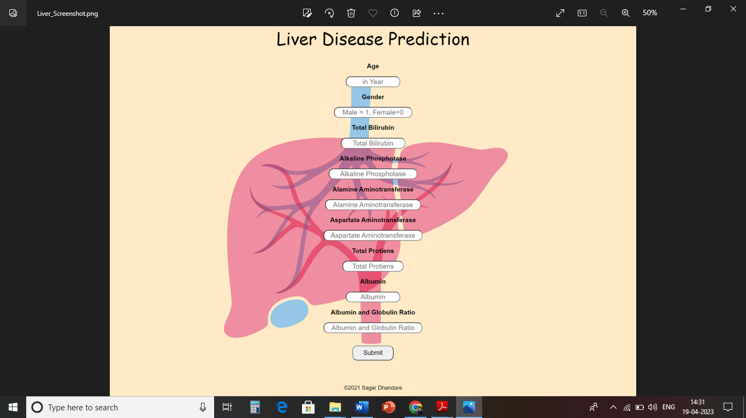

# ADVANTAGES AND DISADVANTAGES

A liver biopsy is a test used to diagnose liver conditions. Tissue samples are removed from your liver and checked under a microscope for signs of damage or disease. A liver biopsy can tell if there are cancer cells or other abnormal cells in your liver. It can also tell how well your liver is working.

# DISADVANTAGES

* Pain. Pain at the biopsy site is the most common complication after a liver biopsy. ...
* Bleeding. Bleeding can occur after a liver biopsy but is not a common complication. ...
* Infection. Rarely, bacteria may enter the abdominal cavity or bloodstream.
* Accidental injury to a nearby organ.

# APPLICATIONS

A group of blood tests called liver function tests can be used to diagnose liver disease. Other blood tests can be done to look for specific liver problems or genetic conditions. Imaging tests. An ultrasound, CT scan and MRI can show liver damage.

# CONCLUSION

Summary. The main roles of the liver include removing toxins, processing food nutrients and regulating body metabolism. Important causes of liver disorders are fatty liver, hepatitis virus infections and alcohol. Cirrhosis (liver scarring), the end-result of many liver disorders, can lead to liver failure.

# FUTURE SCOPE

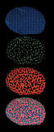

The liver has a unique capacity among organs to regenerate itself after damage. A liver can regrow to a normal size even after up to 90% of it has been removed. But the liver isn't invincible. Many diseases and exposures can harm it beyond the point of repair.

# APPENDIX

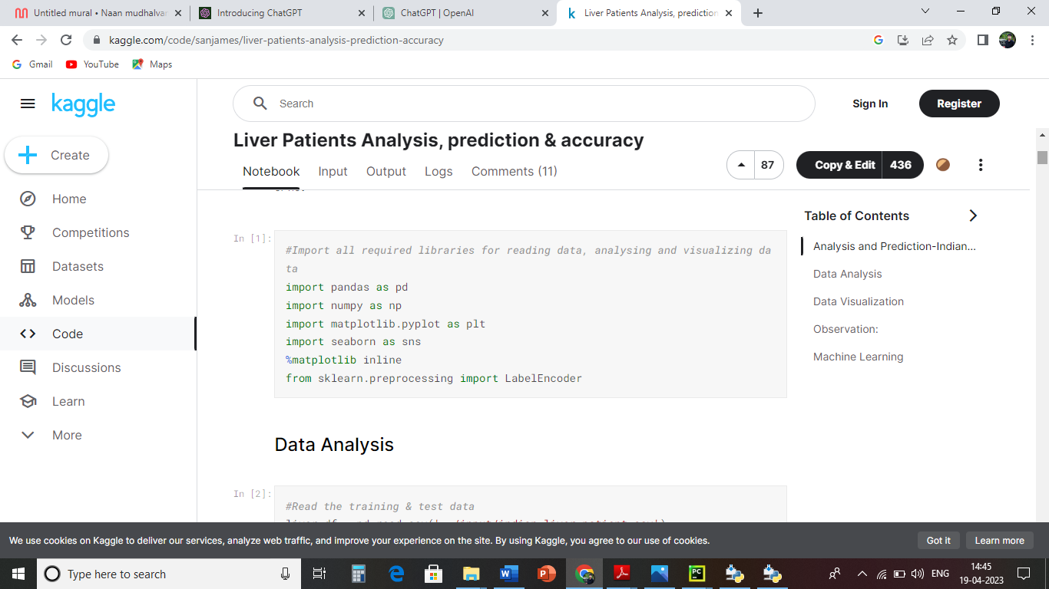

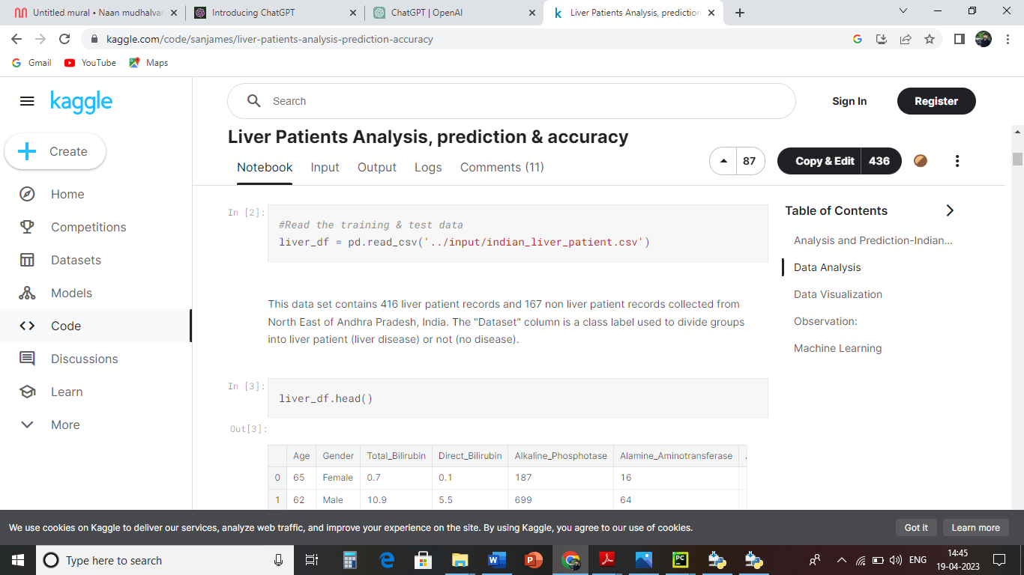

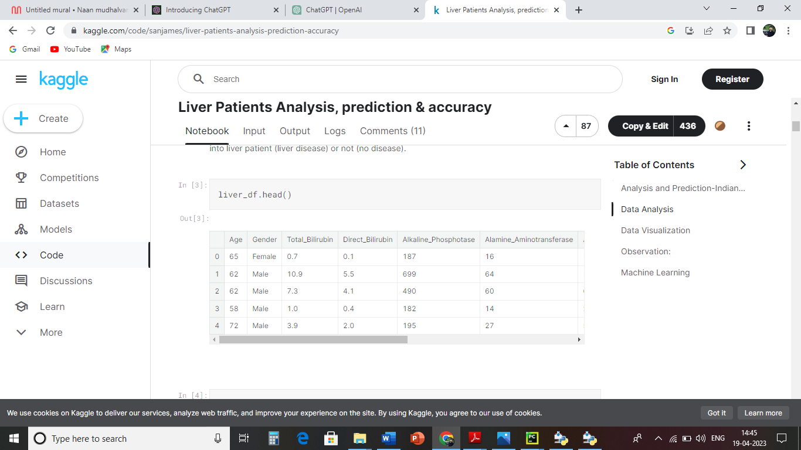

# PROJECT SUCCESSFULLY COMPLETED

TEAM LEADER: AATHISANGARAN

TEAM MEMBER: AKASH

TEAM MEMBER: ANILPRIYA

TEAM MEMBER: AMUTHAVAN